OPENSTACK测试数据

测试一下方面：

1. 网络带宽占用情况
2. 虚机、后端存储磁盘IO使用情况
3. 创建虚机实例测试
   1. 创建虚机时，一次性创建个数最好十个以下。
4. GlusterFS后端存储宕机测试
5. 系统初始化环境测试
6. 虚机中操作对网络节点带宽影响测试

1．创建虚机网络带宽占用情况如下图：

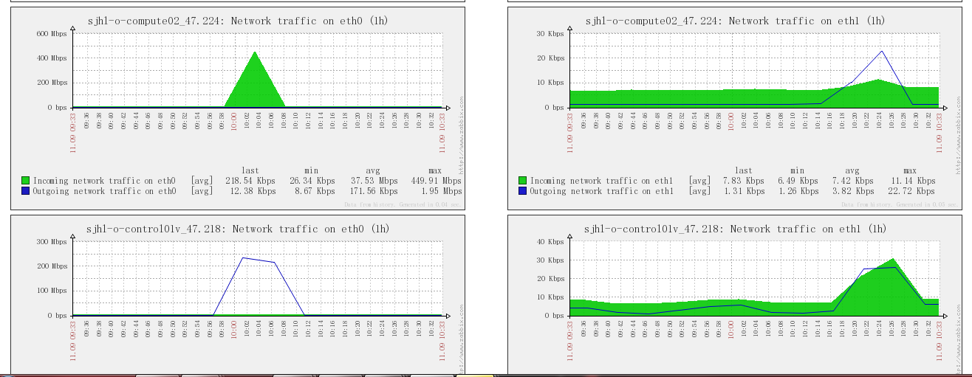

2. 进行满负荷读写操作时：

时间：10:33开始 🡪 10:39完成

# dd if=/dev/zero of=./test.iso bs=100M count=100

速率如下：

100+0 records in

100+0 records out

10485760000 bytes (10 GB) copied, 330.816 s, 31.7 MB/s

3. 网络占用

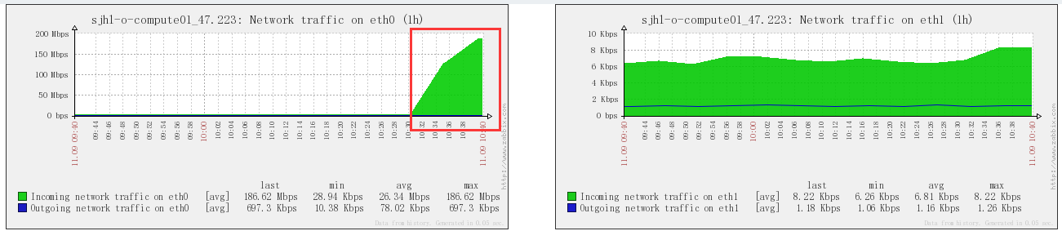

4. 后端GlusterFS服务器IO情况

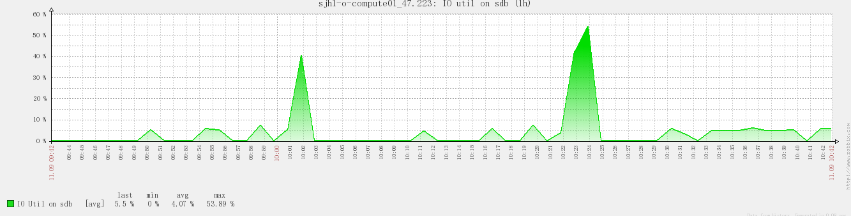

5. GlusterFS宕机测试

仅仅在公司环境测试不会影响。世纪互联没有机器，不能进行操作。

当GlusterFS后端存储宕机一台时

6. 对虚机操作对网络节点带宽影响

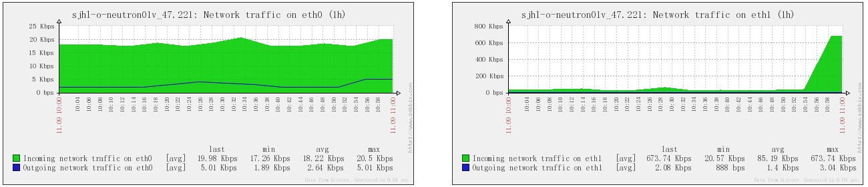

7．在虚机上进行的IO测试

# fio -filename=/dev/vdb1 -direct=1 -iodepth 1 -thread -rw=randrw -rwmixread=70 -ioengine=psync -bs=16k -size=200G -numjobs=30 -runtime=100 -group_reporting -name=mytest -ioscheduler=noop

mytest: (g=0): rw=randrw, bs=16K-16K/16K-16K, ioengine=psync, iodepth=1

...

mytest: (g=0): rw=randrw, bs=16K-16K/16K-16K, ioengine=psync, iodepth=1

fio 2.0.7

Starting 30 threads

Jobs: 30 (f=30): [mmmmmmmmmmmmmmmmmmmmmmmmmmmmmm] [100.0% done] [5712K/2455K /s] [348 /149 iops] [eta 00m:00s]

mytest: (groupid=0, jobs=30): err= 0: pid=2468

read : io=551888KB, bw=5515.3KB/s, iops=344 , runt=100066msec

clat (usec): min=394 , max=335564 , avg=86771.73, stdev=56123.17

lat (usec): min=394 , max=335564 , avg=86772.14, stdev=56123.16

clat percentiles (msec):

| 1.00th=[ 8], 5.00th=[ 20], 10.00th=[ 28], 20.00th=[ 38],

| 30.00th=[ 46], 40.00th=[ 55], 50.00th=[ 68], 60.00th=[ 89],

| 70.00th=[ 122], 80.00th=[ 145], 90.00th=[ 169], 95.00th=[ 188],

| 99.00th=[ 221], 99.50th=[ 235], 99.90th=[ 302], 99.95th=[ 310],

| 99.99th=[ 330]

bw (KB/s) : min= 75, max= 404, per=3.34%, avg=184.41, stdev=44.33

write: io=238224KB, bw=2380.7KB/s, iops=148 , runt=100066msec

clat (usec): min=121 , max=4322 , avg=530.12, stdev=358.87

lat (usec): min=123 , max=4337 , avg=534.78, stdev=359.11

clat percentiles (usec):

| 1.00th=[ 147], 5.00th=[ 179], 10.00th=[ 207], 20.00th=[ 258],

| 30.00th=[ 310], 40.00th=[ 366], 50.00th=[ 430], 60.00th=[ 506],

| 70.00th=[ 596], 80.00th=[ 740], 90.00th=[ 988], 95.00th=[ 1240],

| 99.00th=[ 1816], 99.50th=[ 2024], 99.90th=[ 2832], 99.95th=[ 3792],

| 99.99th=[ 4256]

bw (KB/s) : min= 22, max= 448, per=3.49%, avg=82.96, stdev=44.99

lat (usec) : 250=5.48%, 500=12.44%, 750=6.46%, 1000=2.95%

lat (msec) : 2=2.95%, 4=0.20%, 10=0.62%, 20=2.64%, 50=20.78%

lat (msec) : 100=19.67%, 250=25.64%, 500=0.18%

cpu : usr=0.57%, sys=1.54%, ctx=1796765, majf=0, minf=64003

IO depths : 1=100.0%, 2=0.0%, 4=0.0%, 8=0.0%, 16=0.0%, 32=0.0%, >=64=0.0%

submit : 0=0.0%, 4=100.0%, 8=0.0%, 16=0.0%, 32=0.0%, 64=0.0%, >=64=0.0%

complete : 0=0.0%, 4=100.0%, 8=0.0%, 16=0.0%, 32=0.0%, 64=0.0%, >=64=0.0%

issued : total=r=34493/w=14889/d=0, short=r=0/w=0/d=0

Run status group 0 (all jobs):

READ: io=551888KB, aggrb=5515KB/s, minb=5515KB/s, maxb=5515KB/s, mint=100066msec, maxt=100066msec

WRITE: io=238224KB, aggrb=2380KB/s, minb=2380KB/s, maxb=2380KB/s, mint=100066msec, maxt=100066msec

Disk stats (read/write):

vdb: ios=34537/14885, merge=0/0, ticks=2987113/7440, in_queue=2997490, util=100.00%